# INTRODUCTION

* 1. **Overview**

Event Management is the process of creating and maintaining an event. This process span from the very beginning of planning all the way to post event strategizing.

**1.2 Purpose**

The project aim is to provide real-time knowledge for all the students who have basic knowledge of Salesforce and Looking for a real-time project. This project will also help to those professionals who are in cross-technology and wanted to switch to Salesforce with the help of this project they will gain knowledge and can include into their resume as well.

1. **Problem Definition & Design Thinking**
   1. Empathy Map

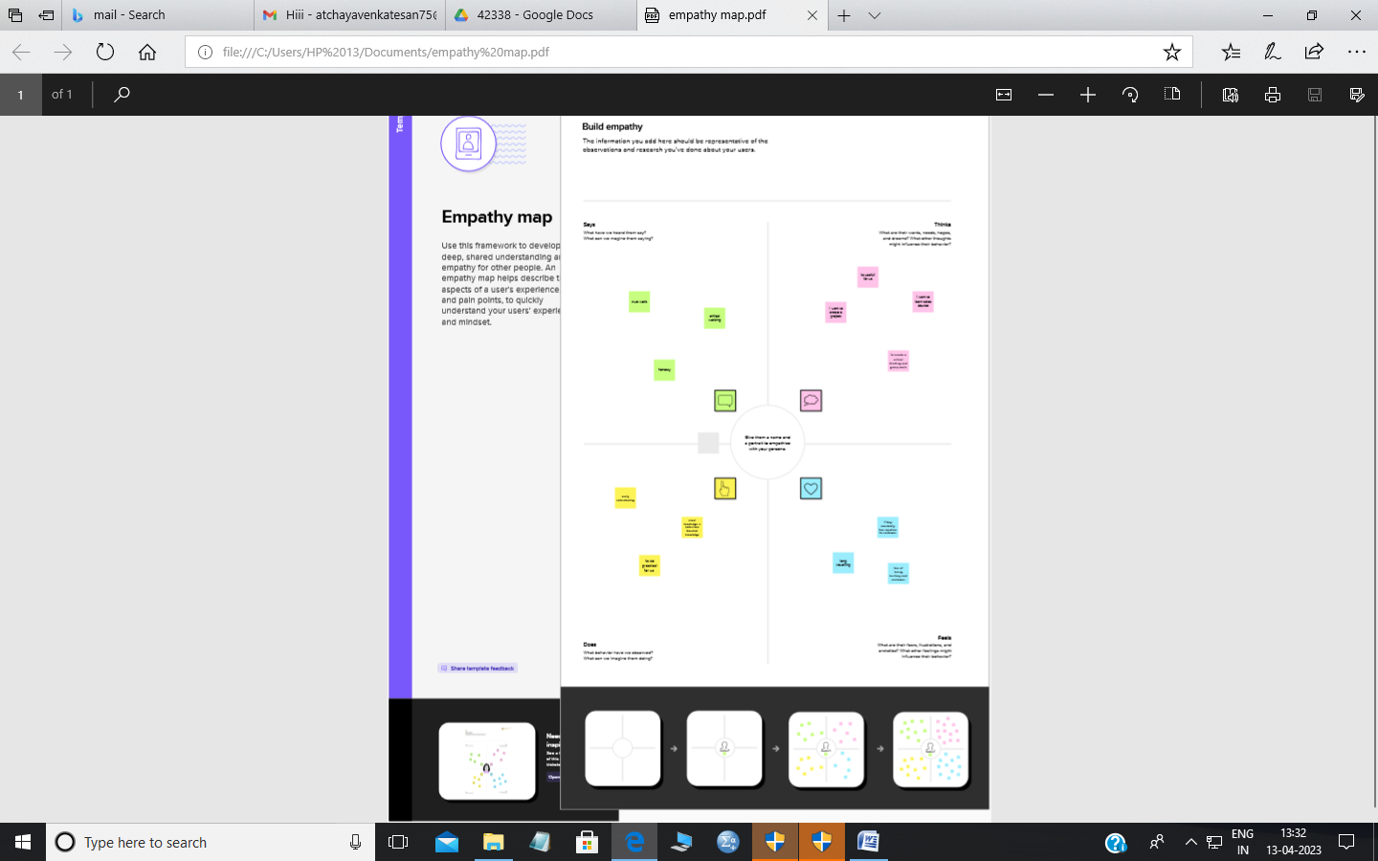

* 1. Ideation & Brainstorming Map

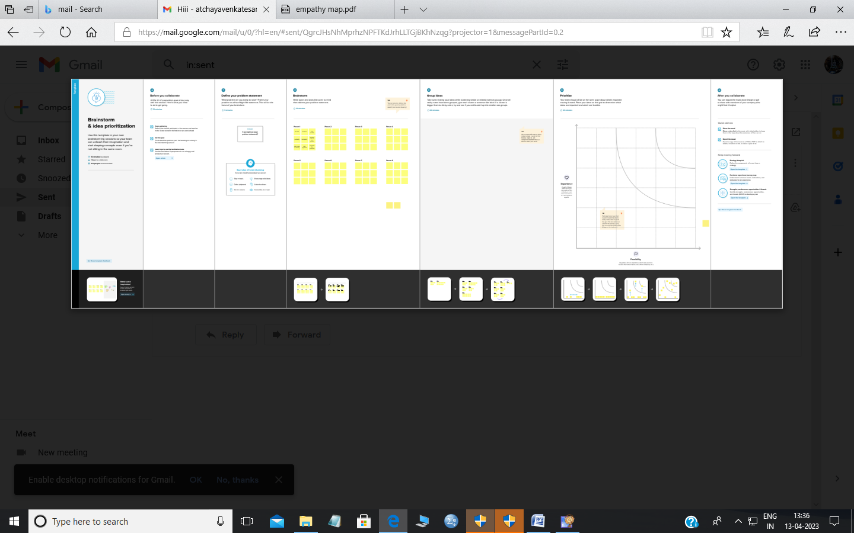

# RESULT

* 1. Data Model:

| **Object name** | **Fields in the Object** |
| --- | --- |
| Events | | **Field Lable** | **Data type** | | --- | --- | | City | Text | | Start Date | Date/time | | End Date | Date/time | |
| Attendees | | **Field Lable** | **Data type** | | --- | --- | | Id | Auto Number | | Phone | Phone | | Email | Email | | Tickets | Picklist | | Event Name | Master-datail Relationship | |
| Speaker | | **Field Lable** | **Data type** | | --- | --- | | Bio | Text Area | | e-mail | Email | | Event Name | Look-up Relationship | |
| Vendors | | **Field Lable** | **Data type** | | --- | --- | | e-mail | Email | | Phone | Phone | | Service provider | Text | | Event Name | Look-up Relationship | |

# Activity & Screenshot

Milestone 1

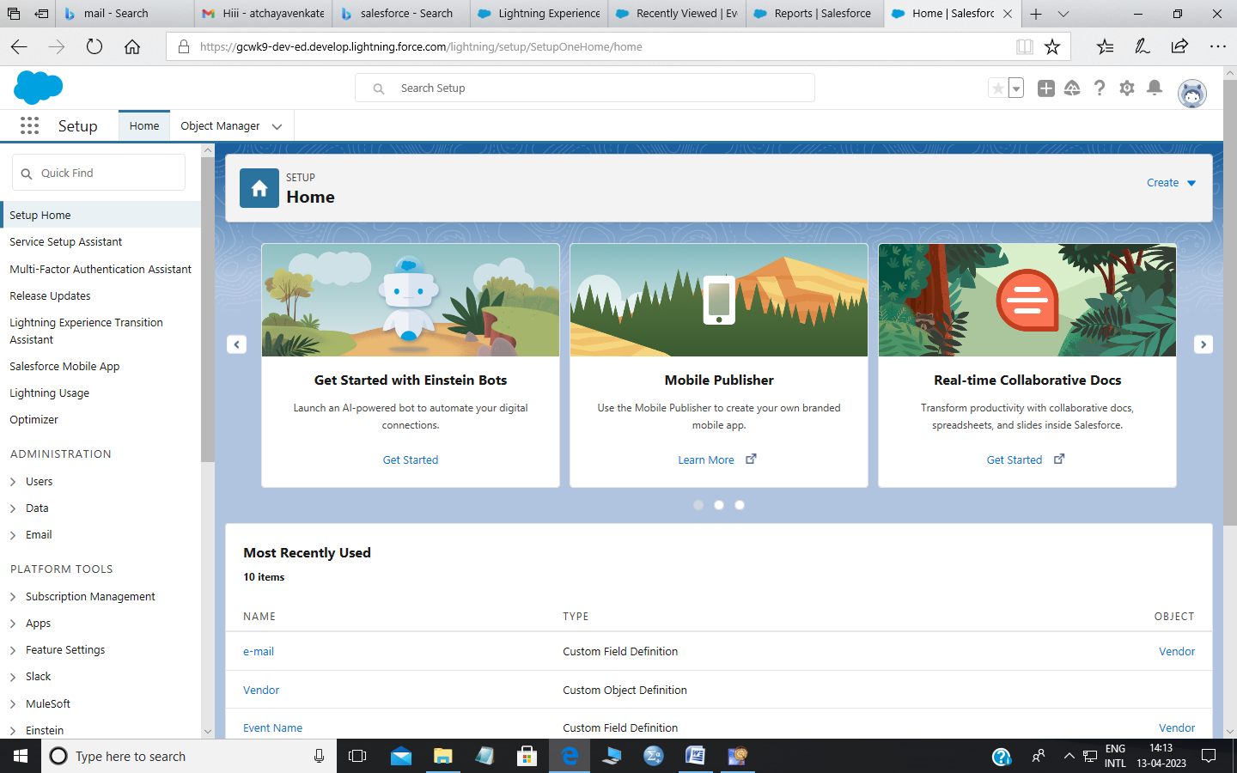

Creation of Salesforce Account

Milestone 2

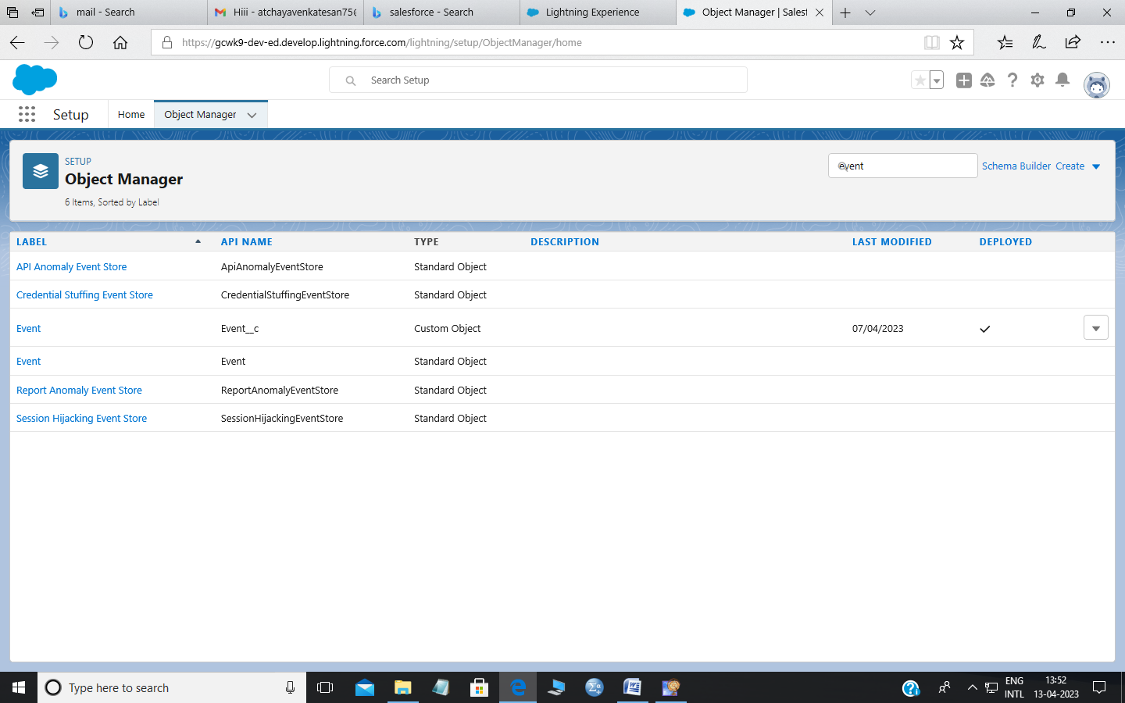

Creation of object for Event Management

Milestone 3

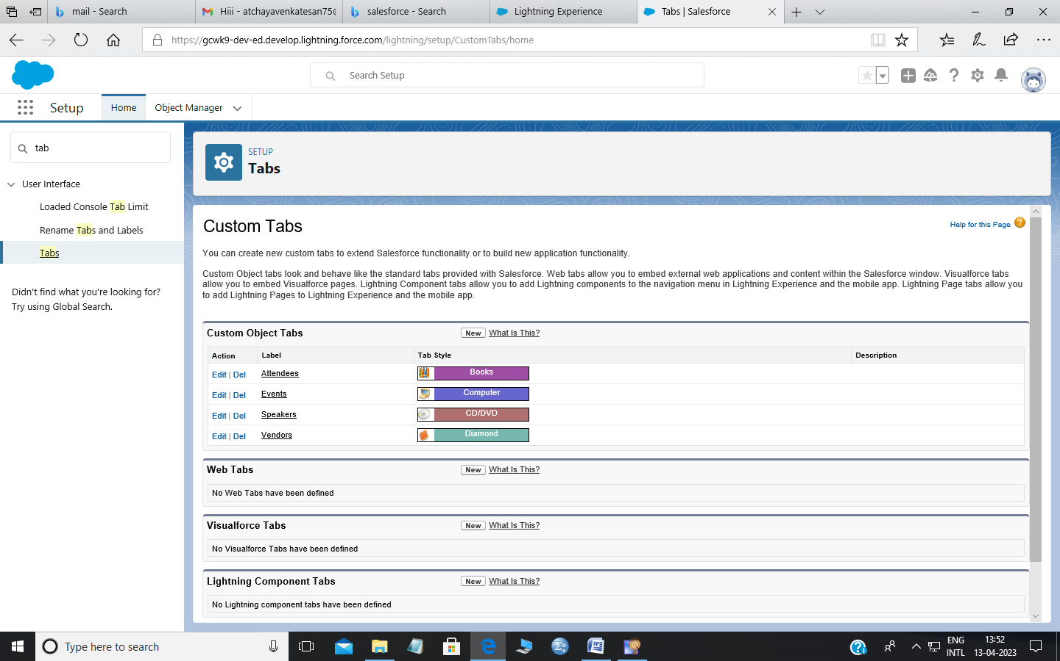

Creation of Event Tab

Milestone 4

Creation of Fields

Creation of Event Field

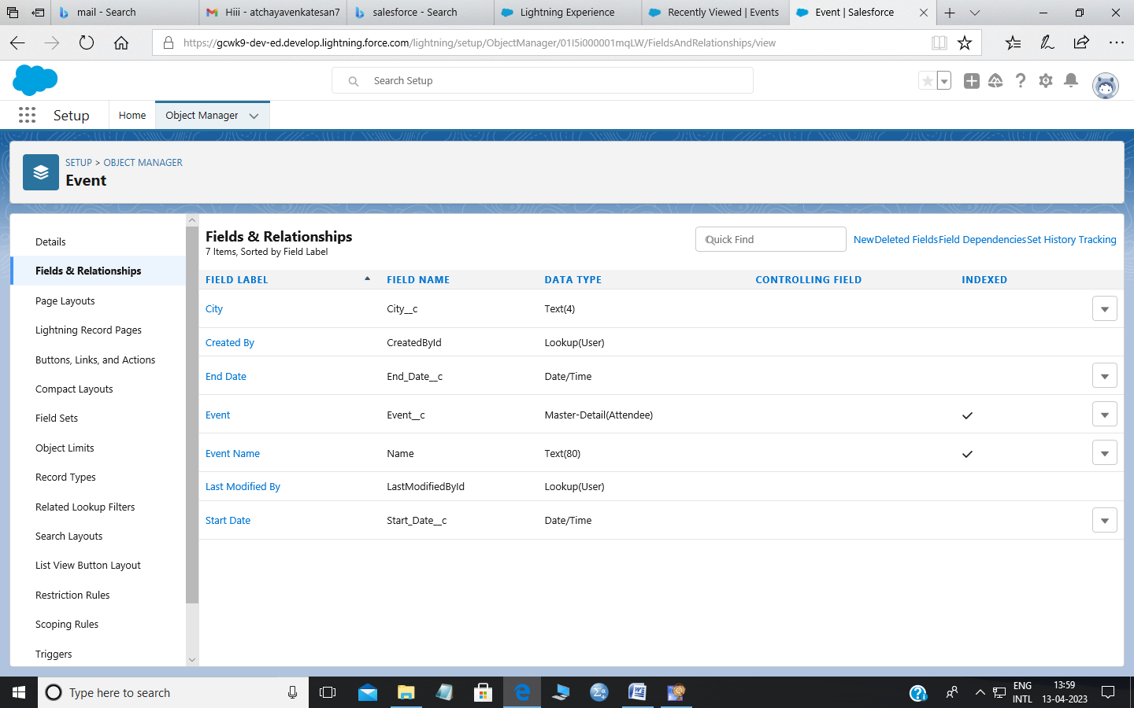

Creation of Attendees Field

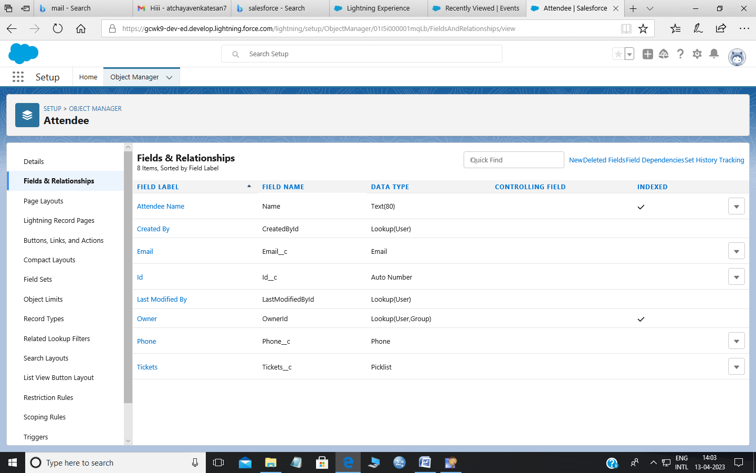

Creation of Speaker Field

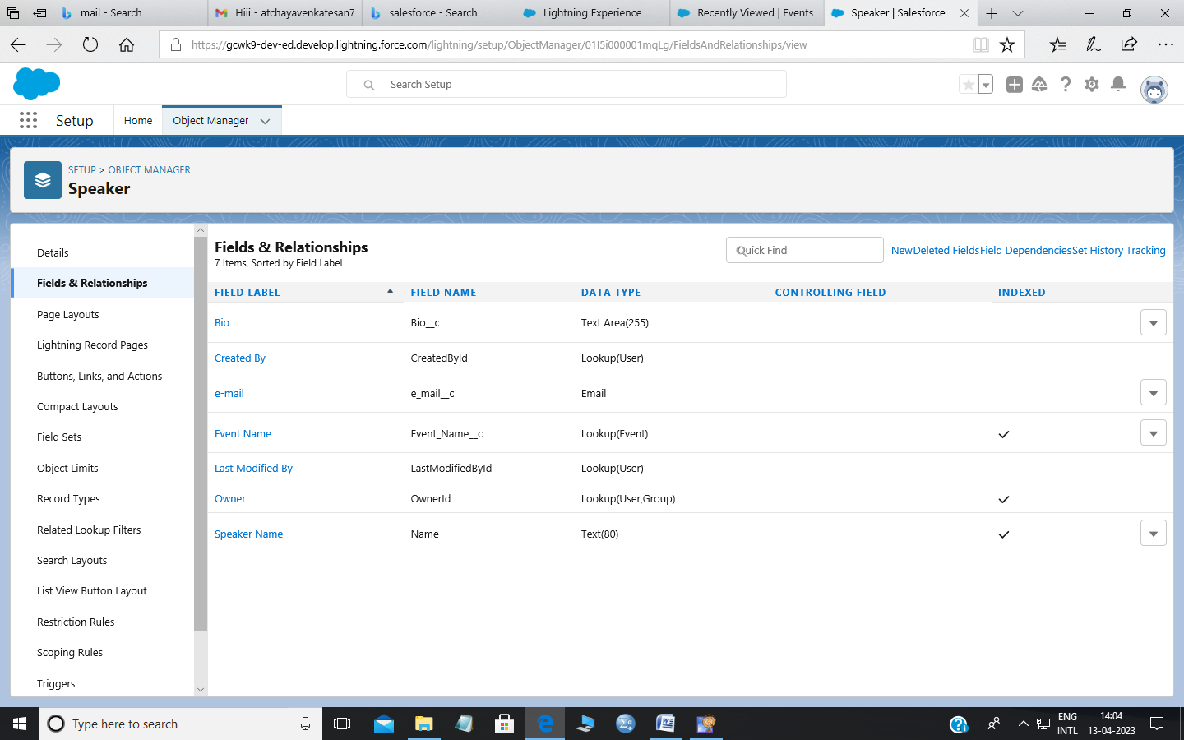

Creation of Vendors Field

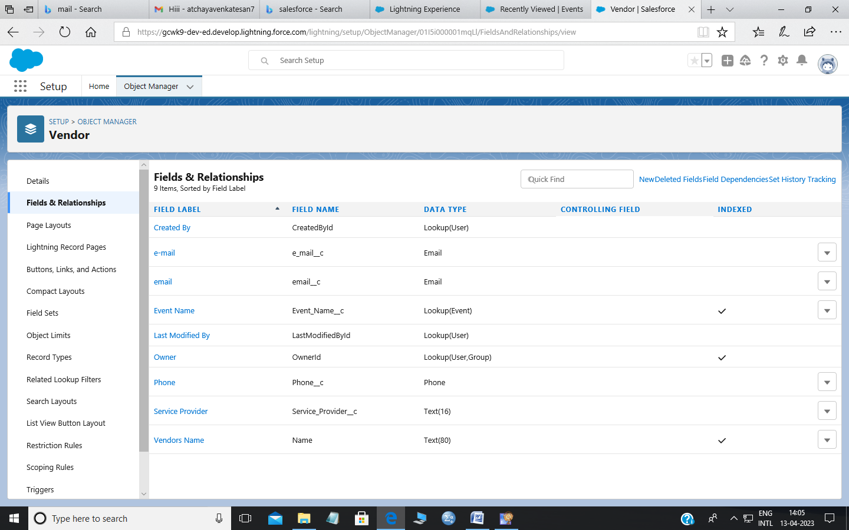

Milestone 5

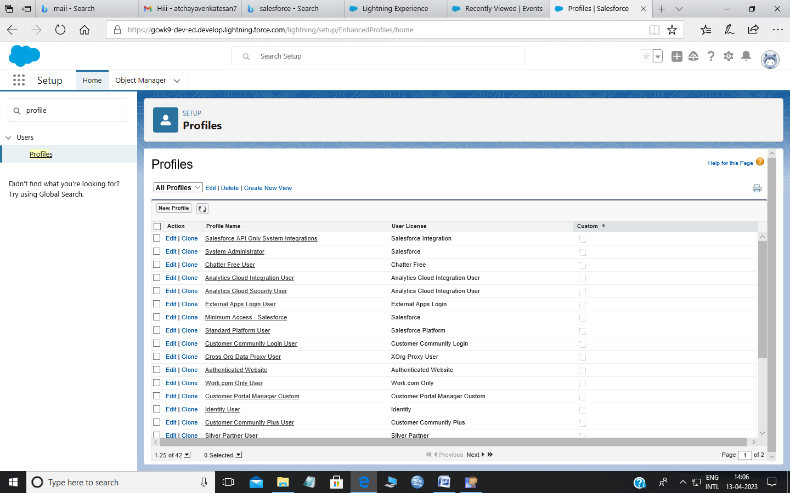

Creation on Profile

Milestone 6

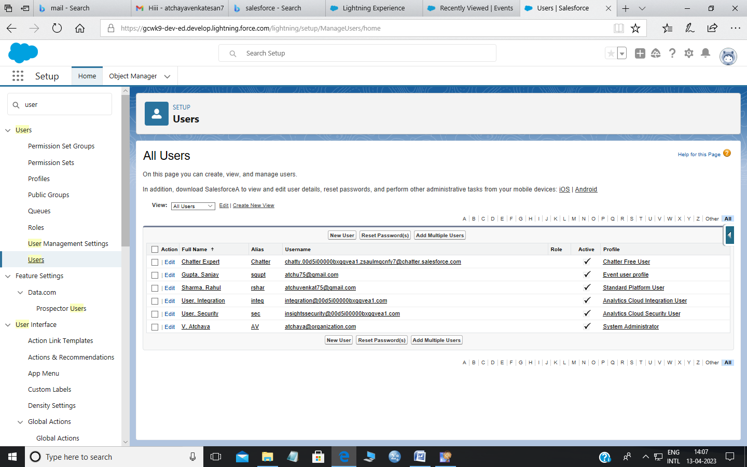

Creation on user

Milestone 7

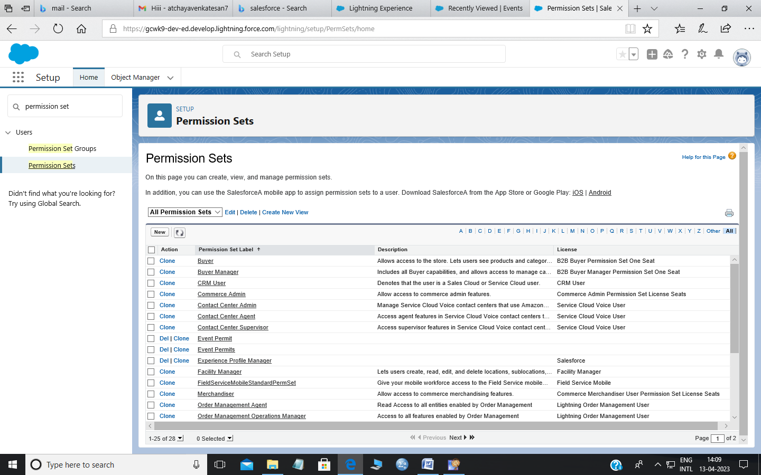

Creation on Premission Sets

Milestone 8

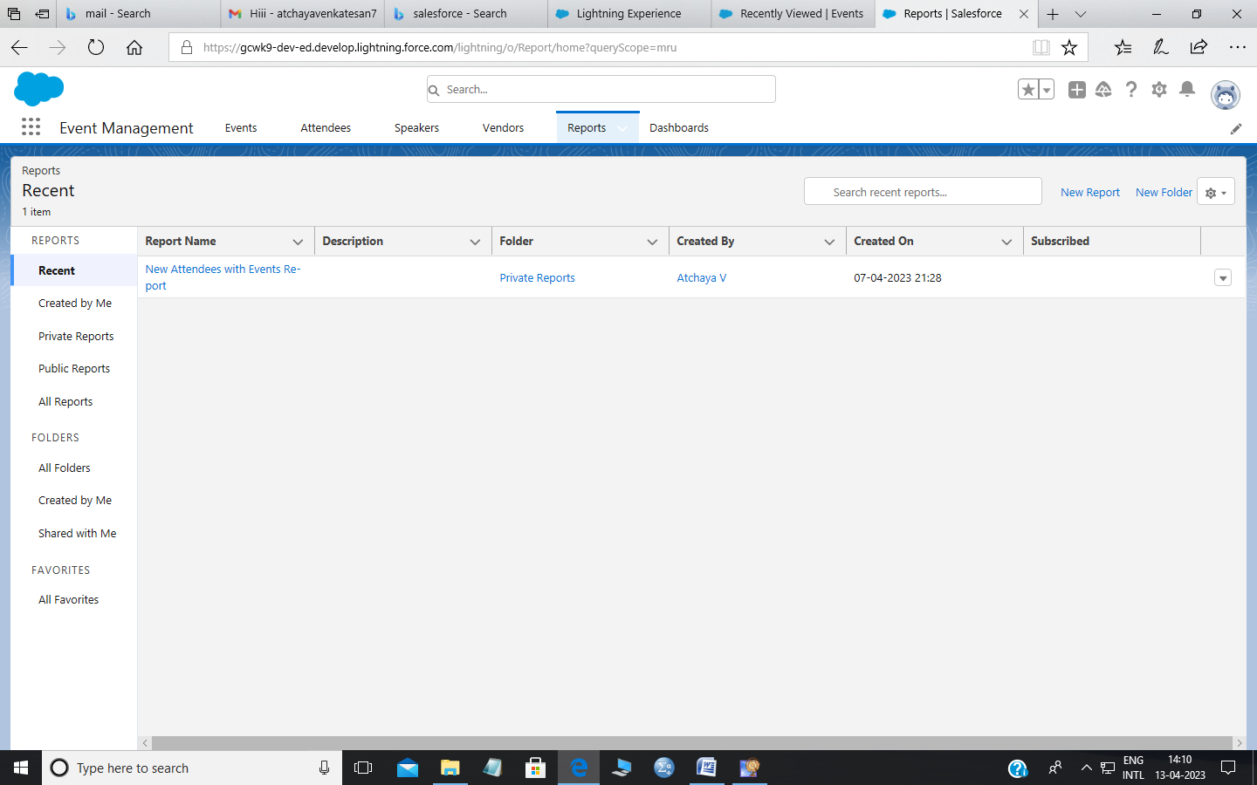

Creating a Report

# Trailhead Profile Public URL

Team Leader – <https://trailblazer.me/id/bramesh36>

Team Member 1 -

[**https://trailblazer.me/id/avenkatesan24**](https://trailblazer.me/id/avenkatesan24)

**Team Member 2 –**

[**https://trailblazer.me/id/bbirundha**](https://trailblazer.me/id/bbirundha)

**Team Member 3 –**

[**https://trailblazer.me/id/dmurugesan2003**](https://trailblazer.me/id/dmurugesan2003)

1. **ADVANTAGES & DISADVANTAGE**

Opportunities for creativity

Collaborative work environment

Time away from family and friends

High level of responsibility

# APPLICATIONS

The abililty to manage distributed audiences in a single platform.

Local support with hardware for in-person events.

Easy event registration & check-in(onsite & online)

# CONCLUSION

Event Management System is user friendly and cost effective system, it is customized with activities related to event management life-cycle.

# FUTURE SCOPE

In the 21st century each and every field is computerized

and all works are done by using the modern technologies so it has

a good future.